tic

(information and communication technologies)

|  |  |
| --- | --- |
| First name | Family name |
| Reda | GUEMAZ |
| Rachid | HAMDAOUI |
| Aymen | BELKADI |
| Mustapha | AINOUCHE |



Table des matières

1. **Introduction**
2. **Overview of Information and Communication Technologies (ICT)**
3. **Google Services**  
   3.1 Gmail  
   3.2 Google Drive  
   3.3 Google Workspace  
   3.4 Google Meet  
   3.5 Google Cloud Platform
4. **Microsoft Tools**  
   4.1 Microsoft Office Suite  
   4.1.1 Word  
   4.1.2 Excel  
   4.1.3 PowerPoint  
   4.2 Microsoft Teams  
   4.3 Azure Cloud Services
5. **GitHub**  
   5.1 Introduction to GitHub  
   5.2 Version Control with Git  
   5.3 Collaboration and Code Sharing  
   5.4 GitHub Projects
6. **Applications in Business Environments**
7. **Case Studies**
8. **Challenges and Future Trends**
9. **Conclusion**
10. **Introduction**

Information and Communication Technologies (ICT) encompass the tools and systems that facilitate the acquisition, processing, storage, and exchange of information. In our daily lives, ICT is essential for various reasons. It forms the backbone of modern communication, enabling instant connectivity through smartphones, emails, and social media. ICT facilitates seamless access to informationmaking knowledge readily available. From online education and remote work to e-commerce and healthcare innovations, ICT enhances efficiency and accessibility. It plays a crucial role in bridging geographical gaps, fostering global collaboration, and supporting economic growth. The integration of ICT in daily tasks, such as banking, navigation, and entertainment, enhances convenience. Overall, ICT is indispensable, empowering individuals and societies by driving innovation, connectivity, and the digital transformation of our everyday experiences.

**2. Overview of Information and Communication Technologies (ICT)**

Information and Communication Technologies (ICT) encompass a broad array of technologies used for the acquisition, storage, processing, and dissemination of information. The evolution of ICT has been transformative, from the advent of the internet to the integration of artificial intelligence. Initially focused on communication, ICT now spans various sectors, including education, healthcare, finance, and industry, revolutionizing how we live and work. Its evolution has witnessed the rise of smartphones, cloud computing, and the Internet of Things (IoT), creating a globally interconnected society. ICT's impact on sectors like business has enhanced efficiency through digital tools, while in healthcare, it has facilitated telemedicine and data-driven diagnostics. The evolution of ICT continues to shape our modern world, influencing innovation, connectivity, and the way we navigate our daily lives.

**3. Google Services**

**3.1 Gmail**

Gmail, Google's email service, excels in communication and collaboration with features such as real-time email synchronization, allowing users to access their messages from various devices seamlessly. The platform supports large file attachments through Google Drive integration, enhancing collaborative file sharing. Advanced search functionalities enable efficient organization and retrieval of emails. Collaborative editing within emails is facilitated with the ability to work on Google Docs directly from Gmail. Labels and categories aid in categorizing and prioritizing messages, streamlining communication. Google Meet integration brings video conferencing directly into the email interface, fostering real-time collaboration. Security features like two-factor authentication and robust spam filtering ensure a secure communication environment. Gmail's chat functionality allows users to engage in instant messaging, encouraging quick communication. The platform's customization options, including themes and priority inbox settings, cater to individual communication preferences. Overall, Gmail stands as a versatile tool, combining effective communication and collaboration features in a user-friendly interface.

the number of gmail users has been steadily increasing and here is a statistics that prove that :

|  |  |  |  |  |  |  |  |  |  |
| --- | --- | --- | --- | --- | --- | --- | --- | --- | --- |
| Years | 2012 | 2013 | 2014 | 2015 | 2016 | 2017 | 2018 | 2019 | 2020_2024 |
| Number of users (million) | 425 | 600 | 750 | 900 | 1000 | 1300 | 1500 | 1700 | +1800 |

**Statisics table that show number of gmail users since 2012**

From **www.demandsage.com**

**3.2 Google Drive**

Google Drive serves as a powerful document storage and collaboration platform, allowing users to store files in the cloud, ensuring accessibility from any device. It facilitates seamless document sharing through shareable links, providing control over access levels. Real-time collaboration features enable multiple users to edit documents simultaneously, enhancing teamwork. Google Drive's integration with other Google Workspace apps streamlines document creation, editing, and collaboration. Granular access control and permissions ensure secure and tailored sharing options for files and folders. The platform's version history feature enables tracking changes and reverting to previous document states. Google Drive supports diverse file formats, including Google Docs, Sheets, and Slides, as well as Microsoft Office files. The search functionality allows users to quickly locate specific files or content within documents. Offline access ensures users can work on documents even without an internet connection. Overall, Google Drive provides a comprehensive solution for document storage, sharing, and collaborative work in a user-friendly and efficient environment.

**3.3** **Google Workspace** Google Drive serves as a powerful document storage and collaboration platform, allowing users to store files in the cloud, ensuring accessibility from any device. It facilitates seamless document sharing through shareable links, providing control over access levels. Real-time collaboration features enable multiple users to edit documents simultaneously, enhancing teamwork. Google Drive's integration with other Google Workspace apps streamlines document creation, editing, and collaboration. Granular access control and permissions ensure secure and tailored sharing options for files and folders. The platform's version history feature enables tracking changes and reverting to previous document states. Google Drive supports diverse file formats, including Google Docs, Sheets, and Slides, as well as Microsoft Office files. The search functionality allows users to quickly locate specific files or content within documents. Offline access ensures users can work on documents even without an internet connection. Overall, Google Drive provides a comprehensive solution for document storage, sharing, and collaborative work in a user-friendly and efficient environment.

**3.4** **Google Meet**

Google Meet is a video conferencing platform within Google Workspace, offering HD video and audio quality for clear communication. With end-to-end encryption, it ensures secure virtual meetings of various sizes. Real-time collaboration, screen sharing, and integration with Google Calendar streamline the meeting process. Live captions and translation features enhance inclusivity, catering to a global audience. Flexible meeting options, including scheduled and recurring meetings, accommodate diverse collaboration scenarios. Meeting recordings enable participants to review discussions later. Hosts have control over participant access, ensuring well-managed meetings. Accessibility features make Google Meet inclusive for users with disabilities. Available as a mobile app, it supports on-the-go remote collaboration, playing a vital role in fostering effective virtual teamwork.

**3.5** **Google Cloud Platform**

Google Cloud Platform (GCP) is a comprehensive suite of cloud computing services offered by Google, providing businesses with scalable and flexible solutions for their IT infrastructure. With a global network of data centers, GCP offers robust and reliable cloud services to support various applications and workloads. Its significance lies in empowering organizations to leverage cutting-edge technologies, including artificial intelligence, machine learning, and big data analytics. GCP's infrastructure-as-a-service (IaaS) and platform-as-a-service (PaaS) offerings enable businesses to deploy, manage, and scale applications efficiently. The platform's emphasis on security and compliance ensures a secure environment for sensitive data and applications. GCP's pay-as-you-go pricing model allows businesses to optimize costs based on their usage, making it cost-effective. With a strong ecosystem of tools and services, GCP accelerates innovation by providing developers with the tools they need to build and deploy applications quickly. Its global reach ensures low-latency access to resources, enhancing performance for users worldwide. GCP's commitment to sustainability, with a goal to operate on 24/7 carbon-free energy by 2030, aligns with environmentally conscious business practices. In essence, Google Cloud Platform stands as a key player in cloud computing, offering businesses the agility, scalability, and advanced capabilities needed to thrive in the digital era.

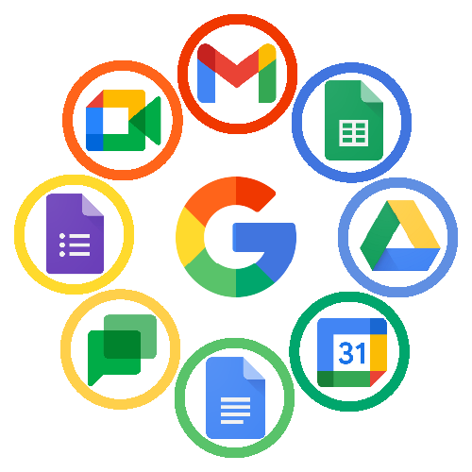Haut du formulaire

**4. Microsoft Tools**

**4.1 Microsoft Office Suite**

* **Word:**
  + Microsoft Word is a versatile word processing tool, allowing users to create, edit, and format documents with a wide range of features, including styles, templates, and collaborative editing.
* **Excel:**
  + Excel is a powerful spreadsheet application, enabling users to analyze and visualize data through functions, charts, and pivot tables, fostering data-driven decision-making.
* **PowerPoint:**
  + PowerPoint facilitates the creation of dynamic presentations with features like slide transitions, animations, and collaboration options, making it an essential tool for communication.

**4.2 Microsoft Teams**

* Microsoft Teams is a collaboration platform that integrates chat, video conferencing, file storage, and application integration, providing a unified workspace for teamwork.

**4.3 Azure Cloud Services**

* Azure is Microsoft's cloud computing platform offering a broad set of services, including virtual machines, databases, and AI tools, empowering organizations to build, deploy, and manage applications in the cloud.

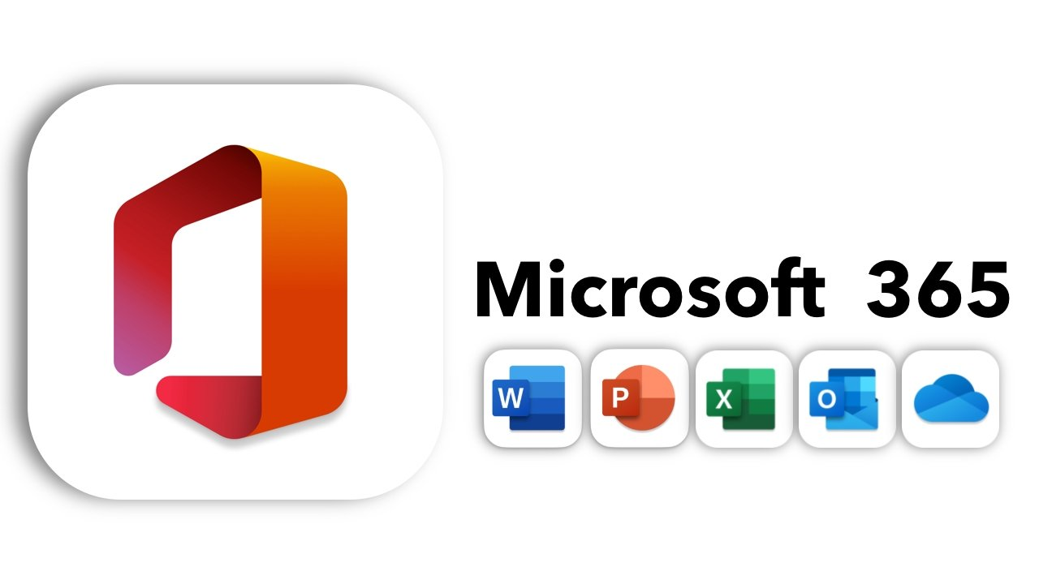

**5. GitHub**

* **5.1 Introduction to GitHub:**
  + GitHub is a web-based platform for version control and collaboration, essential for managing and tracking changes in code repositories.
* **5.2 Version Control with Git:**
  + Git, integrated with GitHub, allows developers to track changes in code, collaborate with others, and manage different versions of their software projects.
* **5.3 Collaboration and Code Sharing:**
  + GitHub fosters collaboration by enabling developers to work on projects concurrently, review code, and contribute through pull requests, ensuring a streamlined development process.
* **5.4 GitHub Projects:**
  + GitHub Projects is a project management feature, providing boards, automation, and tracking tools to help teams organize and prioritize their work efficiently.



**6. Applications in Business Environments**

* Cloud-based applications like Google Workspace and Microsoft 365 enhance collaboration, communication, and productivity within business environments.

**7. Case Studies**

* Present case studies showcasing real-world scenarios where the integration of Google Services, Microsoft Tools, and GitHub has positively impacted organizations in terms of efficiency and collaboration.

**8. Challenges and Future Trends**

* Explore challenges associated with these technologies, such as security concerns and user adoption, and discuss emerging trends, including advancements in AI, automation, and the integration of these technologie

**9. Conclusion**

In conclusion, Information and Communication Technologies (ICT) stand as the cornerstone of our interconnected world, reshaping the way we communicate, work, and live. From the simplicity of everyday tasks to the complexities of global collaboration, ICT has become an indispensable force. The ubiquity of smartphones, the accessibility of the internet, and the integration of advanced technologies like artificial intelligence underscore the transformative power of ICT. In our daily lives, it facilitates instant communication, provides access to information at our fingertips, and propels innovation across diverse sectors. As we navigate an increasingly digital landscape, the role of ICT in education, healthcare, business, and beyond becomes more pronounced. Embracing ICT is not just a choice but a necessity for staying connected, informed, and competitive in a rapidly evolving world. The continued evolution of ICT promises further advancements, influencing the way we interact with technology and each other, ultimately shaping the future of our global society.